## Western Australian Certificate of Education

**Trial Examination, 2016**

##### Question/Answer Booklet

Please place your student identification label in this box

**COMPUTER**

**SCIENCE**

**Units 1 and 2**

|  |  |  |  |  |  |  |  |  |  |  |
| --- | --- | --- | --- | --- | --- | --- | --- | --- | --- | --- |
| Student Number: In figures |  |  |  |  |  |  |  |  |  |  |

In words

**Time allowed for this paper**

Reading time before commencing work: ten minutes

Working time for paper: three hours

**Materials required/recommended for this paper**

***To be provided by the supervisor***

This Question/Answer Booklet

###### *To be provided by the candidate*

Standard items: pens, pencils, eraser, correction fluid/tape, ruler, highlighters

Special items: non-programmable calculators, MATHOMAT and/or Mathaid and/or any system flowchart template

**Important note to candidates**

No other items may be taken into the examination room. It is **your** responsibility to ensure that you do not have any unauthorised notes or other items of a non-personal nature in the examination room. If you have any unauthorised material with you, hand it to the supervisor **before** reading any further.

**Structure of this paper**

|  |  |  |  |  |  |
| --- | --- | --- | --- | --- | --- |
| Section | Number of questions available | Number of questions to be answered | Suggested working time (minutes) | Marks available | Percentage of exam |
| Section One:  Short answer | 20 | 20 | 70 | 66 | 40 |
| Section Two:  Extended answer | 4 | 4 | 110 | 85 | 60 |
|  |  |  |  | **Total** | 100 |

**Instructions to candidates**

1. The rules for the conduct of Western Australian external examinations are detailed in the *Year 12 Information Handbook 2016*. Sitting this examination implies that you agree to abide by these rules.

2. Write your answers in the spaces provided in this Question/Answer Booklet. A blue or black ballpoint or ink pen should be used. Wherever appropriate, fully labelled diagrams, tables and examples should be used to illustrate and support your answers.

3. You must be careful to confine your responses to the specific questions asked and to follow any instructions that are specific to a particular question. Where no specific instructions are given, you should feel free to use a range of formats to express your knowledge and understandings.

4. Spare pages are included at the end of this booklet. They can be used for planning your responses and/or as additional space if required to continue an answer.

* Planning: If you use the spare pages for planning, indicate this clearly at the top of the page.
  + Continuing an answer: If you need to use the space to continue an answer, indicate in the original answer space where the answer is continued, i.e. give the page number. Fill in the number of the question(s) that you are continuing to answer at the top of the page.

**Section One: Short answer 40% (66 marks)**

This section contains **20** questions. You must answer **all** questions. Write your answers in the spaces provided.

Spare pages are included at the end of this booklet. They can be used for planning your responses and/or as additional space if required to continue to answer.

* Planning: If you use the spare pages for planning, indicate this clearly at the top of the page.
* Continuing an answer: If you need to use the space to continue an answer, indicate in the original answer space where the answer is continued, i.e. give the page number. Fill in the number of the question that you are continuing to answer at the top of the page.

Suggested working time: 70 minutes.

**Question 1 (1 mark)**

Identify an activity that occurs in the Preliminary Analysis stage of the System Development Life Cycle

**Question 2 (1 mark)**

At which stage of the Systems Development Life Cycle would hardware acquisition be undertaken?

**Question 3 (2 marks)**

Identify key defining characteristics of two (2) different types’ transmission media.

|  |  |
| --- | --- |
| **Transmission Media** | **Characteristic** |
|  |  |
|  |  |

**Question 4 (4 marks)**

Complete the table below by listing four different types of communication networks and briefly describing a key characteristic of each one. One is listed for you.

|  |  |
| --- | --- |
| **Communication Network** | **Characteristic** |
| LAN: Local Area Network |  |
|  |  |
|  |  |
|  |  |

**Question 5 (1 mark)**

Explain what an algorithm is.

**Question 6 (3 marks)**

Describe how the following three programming errors occur ***and*** identify a method likely to be used to detect and/or prevent them.

Logic:

Syntax:

Run time:

**Question 7 (3 marks)**

Refer to the following code

Program WATown

If town = name

RETURN true

ELSE

RETURN false

END IF

END

1. Describe the purpose of this code. ( 2 marks)

1. What data type is the variable “Town”? (1 mark)

**Questions 8 and 9 refer to the following information (2 marks)**

PC X: Quad Core, clock speed 2.5GHz.

PC Y: Single core with clock speed 4.5 Ghz

**Question 8**

Justify which processor you think is likely to process instructions more quickly. (2 marks)

**Question 9 (3 marks)**

1. Why is it important for these computers to have an appropriate amount of RAM? (1 mark)

1. Discuss the purpose of two other types of memory within these systems and their impact on the efficiency of processing. (2 marks)

Memory Type 1:

Memory Type 2:

**Question 10 (2 marks)**

The header of a packet being routed over a network contains information used by the internet layer to forward packets between hosts.

1. What is meant by the term ‘routed’? (1 mark)

1. Describe a method a sender can use to ensure their packet arrives without being intercepted or corrupted? (1 mark)

**Question 11 (2 marks)**

Describe the function of a

switch:

firewall:

**Question 12 (6 marks)**

Identify the stages of the Software Development Cycle by completing the table below. Match an activity (A – F) with the stages of the SDC.

|  |  |
| --- | --- |
| A | Converting pseudocode to high-level language |
| B | Identify inputs and outputs of the system |
| C | Break down program into smaller chunks |
| D | Adjust to ensure compatibility with operating system |
| C | Debugging |
| E | Test plan |
| F | Requirements Plan |

|  |  |
| --- | --- |
| **Software Development Cycle Stages** | **Activity (A – F)** |
|  |  |
|  |  |
|  |  |
|  |  |
|  |  |

**Question 13 (12 marks)**

An algorithm is required to:

1. Set a value of “Lion” to the variable Answer
2. input a user’s answer into a variable Guess
3. If the user enters ‘Lion” the program outputs “Yes they are the biggest cat!”
4. Continue the game until the answer “Lion” or “lion” is reached.
5. Identify all the variables to be used in this program (2 marks)

1. Identify the control structures to be used in this algorithm (2 marks)

1. Complete the pseudocode below declaring all variables, their type and length before the program begins. (8 marks)

Program: Guess the Biggest Cat

var

**Question 14 (3 marks)**

**Product**

|  |  |  |  |  |
| --- | --- | --- | --- | --- |
| **Prod_Code** | **Prod_Name** | **Prod_Cost** | **Supp_Code** | **Qty** |
| 1122AA | ThingyThongs | 10.50 | 21 | 155 |
| 3222EC | RunnerRuns | 58.50 | 25 | 20 |
| 1122AC | ComfStuff | 21.75 | 21 | 50 |
| 4562DA | Swagg | 85 | 27 | 20 |
| 4563FX | Irresistable | 47.8 | 27 | 45 |
| 895GG | Stompystomps | 25 | 25 | 65 |

**Supplier**

|  |  |  |
| --- | --- | --- |
| **Suppl_Code** | **Supp_Name** | **Supp_postcode** |
| 21 | Comfiesforus | 6055 |
| 25 | Priceybutnice | 6050 |
| 27 | Swaggers | 6000 |

1. Identify the Primary key fields for both tables. (2 marks)

1. Using data from the tables, describe how the relationship between Product and supplier has been created? (1 mark)

**Question 15 (4 marks)**

Explain, with reference to both memory and the processor, how a computer processes instructions.

**Question 16 (7 marks)**

Daisy collects information using the following form to collect input information into her database.

Username :

**Enter Your user name ur system username**

Enter New Client Data here

Logout yes/no

Enter Credit card Number:

New Client Street Address:

New Client email:

New Client first name:

New Client Postcode:

New Client Gender:

New Client Surname:

New Client Telephone No

New Client Suburb:

1. Identify a navigational issue with the design of this interface. (1 mark)

1. Identify two (2) design issues with this interface. (2 marks)

Design Issue 1:

Design Issue 2:

1. Daisy is collecting the data and storing it into a database stored on her USB that she carries in her handbag. (4 marks)
2. Outline two security issues with this practise. (2 marks)

1. Discuss two aspects of the legal obligations Daisy should be aware of when storing the data in this manner. (2 marks)

**Question 17 (2 marks)**

A computer’s main memory consists of both volatile and non-volatile memory.

1. Explain what is meant by volatile memory:

1. What is usually stored in non-volatile memory:

**Question 18 (1 mark)**

Discuss the difference between a bridge and a router.

**Question 19 (5 marks)**

These code snippets refer to the array: arr[“Alice”, “Reggie”, “Polly”, “Bruce”, “David”]

|  |  |  |
| --- | --- | --- |
| **Algorithm 1** |  | **Algorithm 2** |
| x “Polly”  matched false  i 0  WHILE i < 5  if arr[i] = x THEN  matched true  ENDIF  i = i + 1  ENDWHILE |  | x “Polly”  matched false  i 0  WHILE i < 5 AND matched false  if arr[i] = x THEN  matched true  ENDIF  i = i + 1  ENDWHILE |

1. Create a trace table for each of the code snippets below(4 marks)

|  |  |  |  |  |
| --- | --- | --- | --- | --- |
| **Trace Algorithm 1** | |  | **Trace Algorithm 2** | |
| matched | i |  | matched | i |
|  |  |  |  |  |
|  |  |  |  |  |
|  |  |  |  |  |
|  |  |  |  |  |
|  |  |  |  |  |
|  |  |  |  |  |

1. Explain why **algorithm 2** may be considered a better solution?(1 mark)

**Question 20 (2 marks)**

1. Convert the decimal number 83 to binary (1 mark)

1. Convert 10101000 to decimal (1 mark)

This page has been left blank intentionally

**End of Section One**

**Section Two: Extended answer 60% (85 Marks)**

This section has **four (4)** questions. Answer **all** questions. Write your answers in the spaces provided.

Spare pages are included at the end of this booklet. They can be used for planning your responses and/or as additional space if required to continue to answer.

* Planning: If you use the spare pages for planning, indicate this clearly at the top of the page.
* Continuing an answer: If you need to use the space to continue an answer, indicate in the original answer space where the answer is continued, i.e. give the page number. Fill in the number of the question that you are continuing to answer at the top of the page.

Suggested working time: 110 minutes.

Questions 21 through to 24 refer to the following information.

Furclass fly pets around the country. Based in Perth, Furclass have many repeat customers who traverse the country taking their pets with them on holiday or for temporary relocation for work purposes.

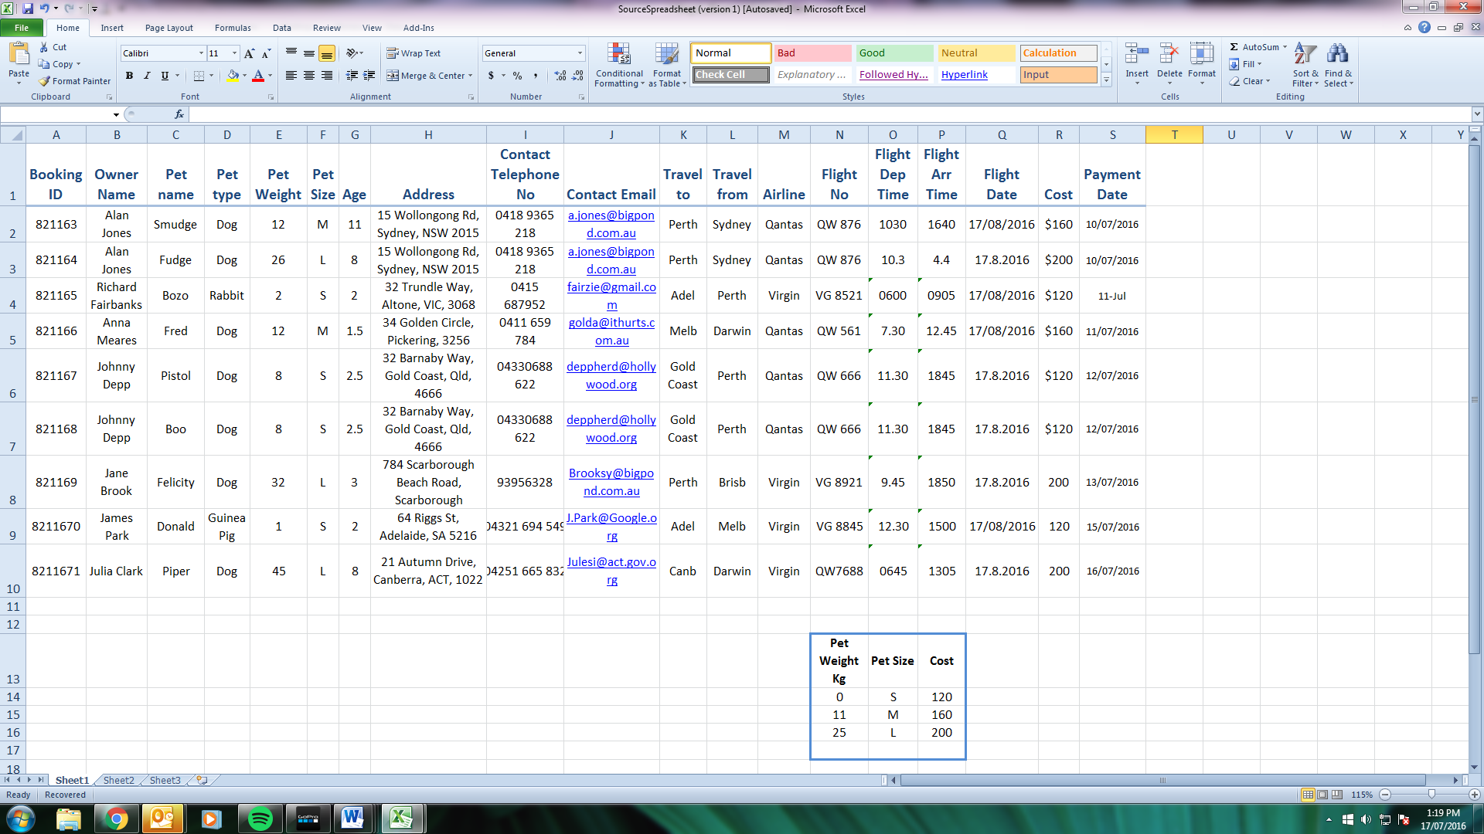Currently they use a spreadsheet (Image 1) to keep track of their customer’s pets and flight bookings.

**Question 21 (18 marks)**

1. Explain what is meant by the term ‘function’ within a spreadsheet (1 mark)

1. The owners of Furclass have been advised that a Vlookup, referring to pet size and travel cost (N13 through to P16) can be used on two columns in this spreadsheet to make input more efficient. (9 marks)
2. Why would columns F and R use Vlookups (1 mark)

1. Write the Vlookup equation that would be contained in these columns? (8 marks)

Column 1:

Column2:

Furclass have been advised by the analyst that they should migrate to a Relational Database Management System (RDBMS).

1. Explain what a RDBMS is and why Furclass should consider moving to one. (2 marks)

1. The following business rules can be concluded from the spreadsheet data.

* An owner can fly more than one pet at the same time with Furclass
* An owner can have more than one booking but a booking only has one pet
* A pet has only one owner
* A booking can have only one flight
* A flight can have many bookings
* A flight can only have one airline
* An airline can have many flights

Complete an entity relationship diagram (ERD) for Furclass indicating cardinality, primary keys and foreign keys (7 marks)

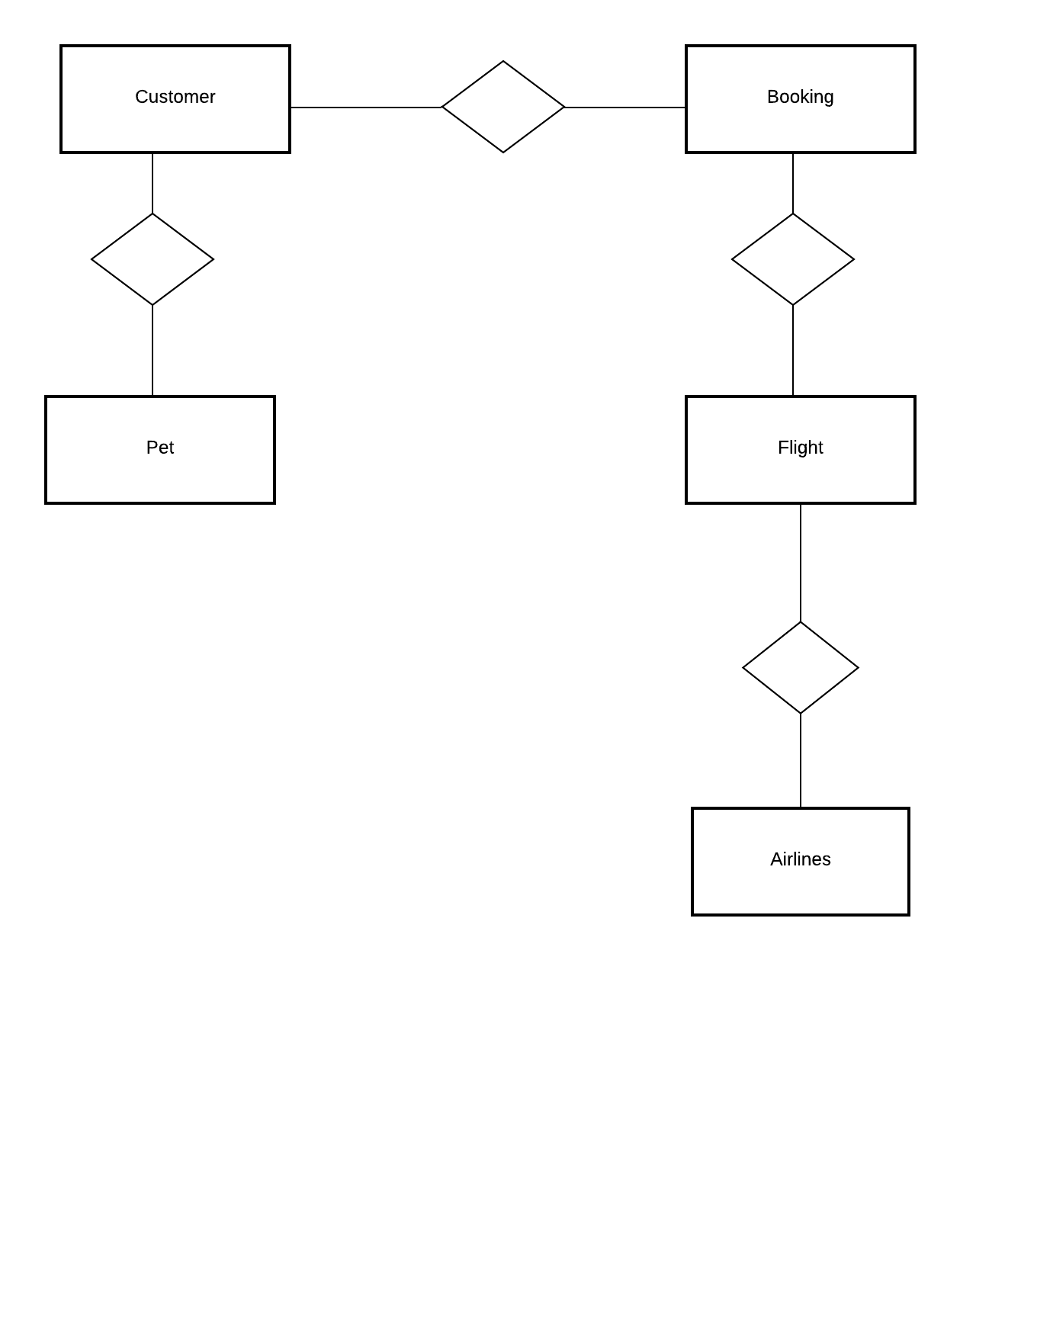**Question 22 (26 marks)**

Furclass are aware that their current arrangements will not suit the expansion of demand they are currently experiencing. They have hired both a systems analyst and a systems designer to develop their processes so that their system is ready for this expansion.

Furclass have a set budget and a timeline that they must have the new system designed by in order to minimise any disruption to the services that they provide.

1. In this situation, identify a project management technique and describe how they will help in the design and implementation of this project. (1 mark)

1. Furclass is unsure whether they should undertake a structured approach to system development or use the prototype approach.

Define each approach and justify which one Furclass should use. (4 marks)

The system analyst has identified the following additional information when a booking is made for a pet

1. The customer contacts Furclass to set enquire about travel dates/times.
2. The customer provides the preferred travel date and the consultant will contact the airlines via an Australia-wide online database to establish what flights are available and at what time.
3. Furclass consultants will ask for details of the owners and the pets including the owners address and contact details, pet(s) size, name, medical conditions etc.
4. The cost of each pet is calculated upon the size of the pet. More specifically, the size of the crate that they are put in to travel. The plane calculates the cost to charge Furclass based on the amount of space the crate takes up
5. The flight details with the travel quotation are provided to the customer and these details, along with the customer details are stored.
6. Upon acceptance by the customer a booking is made and a confirmation email of invoice outlining cost, flight times and dates is emailed to the customer. The booking is then stored. The invoice is also stored in the accounts database.
7. The customer will then arrange payment of invoice via credit card. Payment for bookings must be made four days before the flight if possible.
8. At the end of each month, Furclass receive an accounte from both Qantas and Virgin that they match to the paid bookings in their database. They will then pay the account once it is balanced against the bookings in their system and their accounts database is updated.
9. If it is not balanced, Furclass will raise a dispute which is resolved once either a credit has been issued or documentation proving the booking has been provided by airline.
10. Complete the context diagram below for the Furclass Booking System. (8 marks)

Customer

Airlines

1. Complete the Level 0 Data Flow Diagram below (process 5 has been completed for you).

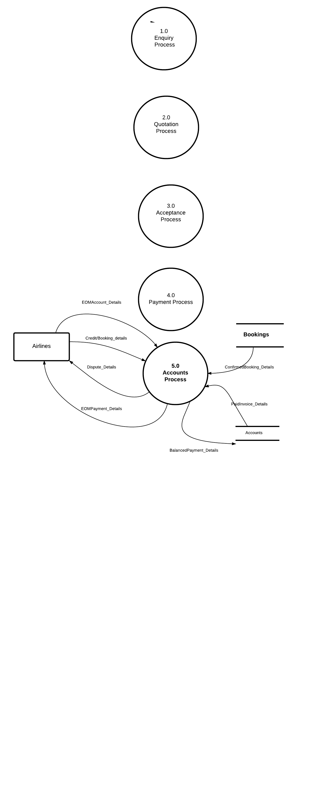

(12 marks)

**Question 23 (22 marks)**

In the move to an online database, Furclass will need a program that customers can interact with and obtain a quote for their pets air travel.

Furclass have decided that their pricing structure for intra-state (within the state) travel will be 75% of the price of the interstate travel cost.

The following pricing structure based on Pet Size for inter-state travel will be used.

|  |  |
| --- | --- |
| **Pet size** | **Price** |
| S | $120 |
| M | $140 |
| L | $160 |

You are to write a program that will provide a quotation for **1 or more pets** from a client who may be travelling either inter or intra state.

1. Identify all the variables and variable type likely to be used in this program. (5 marks)

1. Furclass have been advised that a while loop and a multi-way decision structure will be used in the program.

Discuss how and why these control structures would be used. (4 marks)

1. Write the algorithm that calculates and outputs the statement “The total cost for your pet travel is $..” (13 marks)

Program: Pet Travel Quotation

Var

Begin

**Question 24 (19 marks)**

This question refers to the following network diagram which represents the new network infrastructure for Furclass.

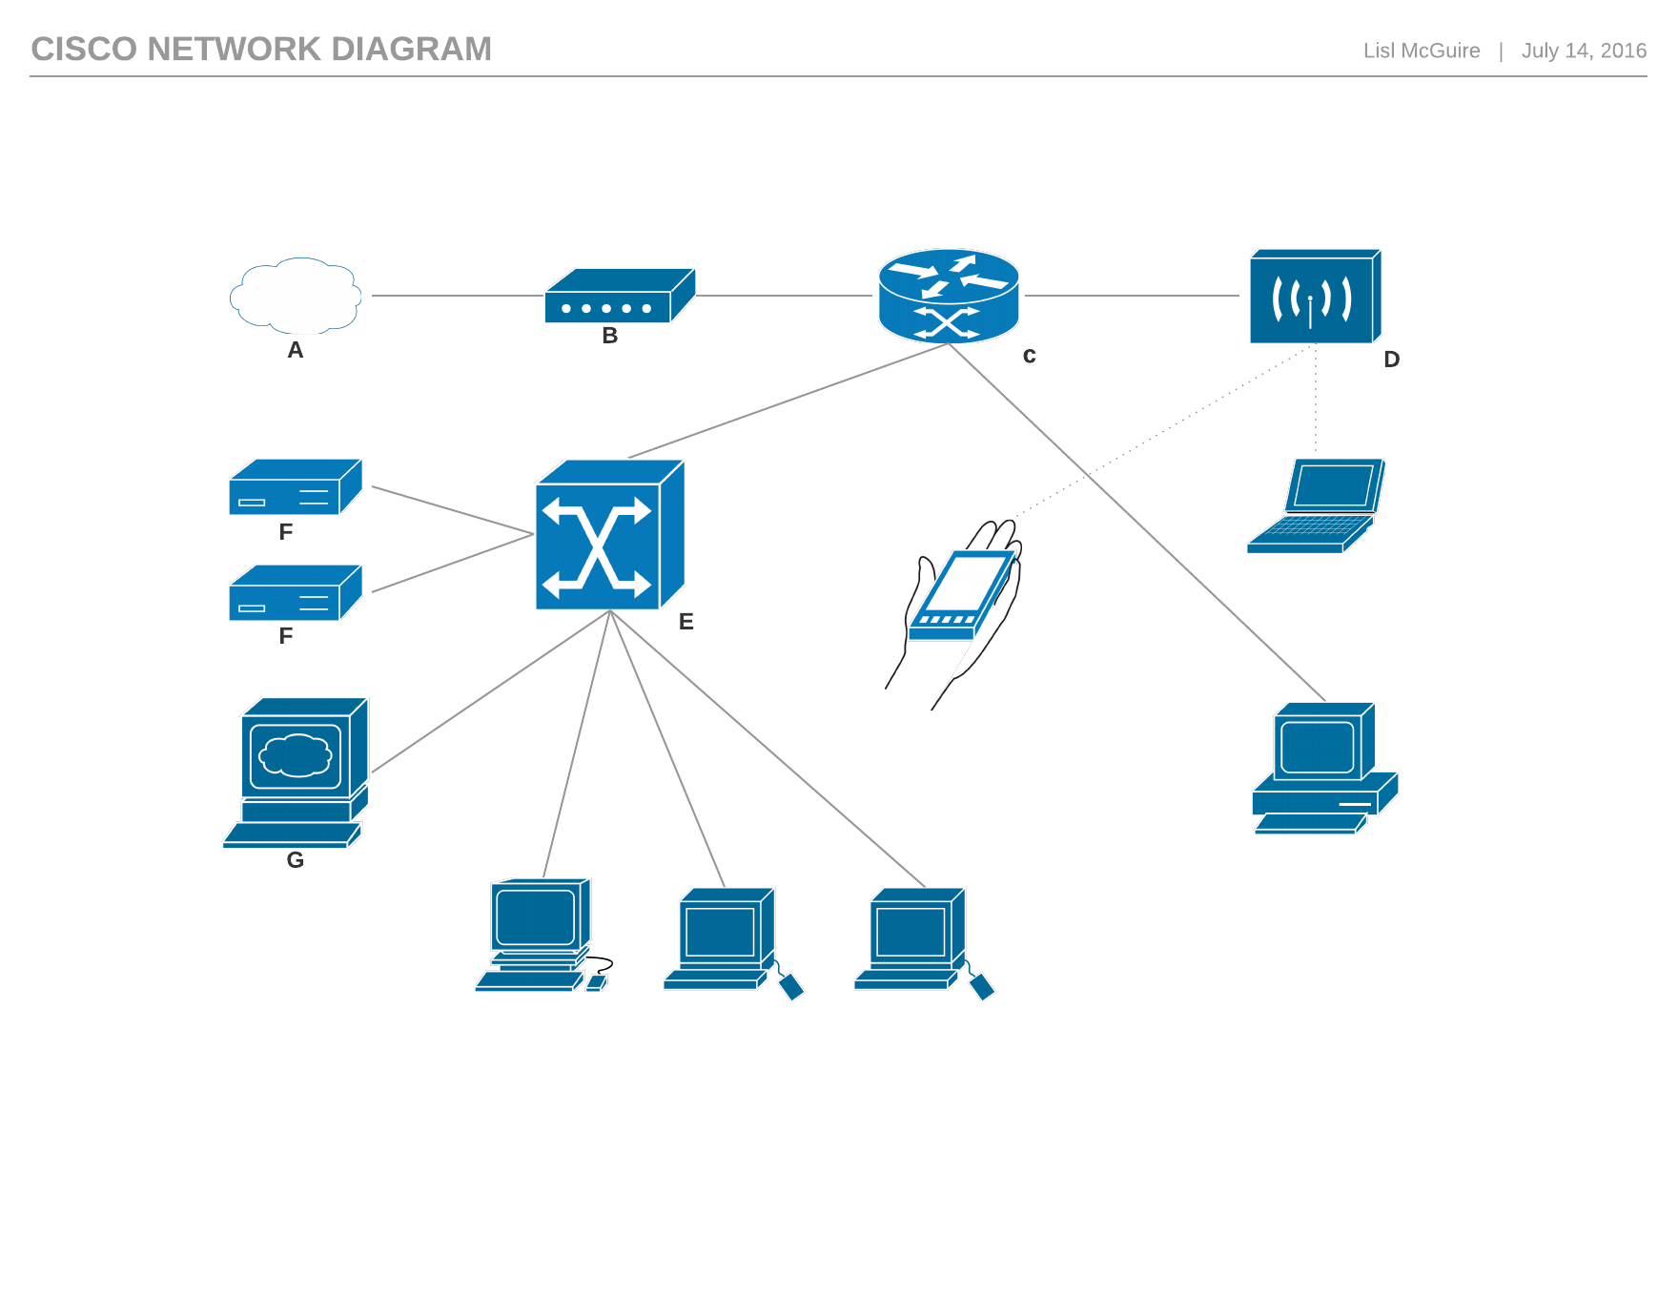

**F**

Workstations

1. The Workstations are all working fine but Furclass have noticed that no-one is able to connect to the internet via their mobile devices.

Explain which device (A, B, C, D, E, F or G) is likely to be experiencing problems and why you have come to this conclusion. (2 marks)

1. What sort of topology does this most resemble? Justify your choice. (2 marks)

1. Identify two (2) different security measures that could be deployed on *this* network to keep data safe from interception **and** intrusion. (2 marks)

Interception:

Intrusion:

1. Furclass have been told that they should develop a Code of Conduct for users of their network. (6 marks)
2. What is a Code of Conduct and why would Furclass develop one? (2 marks)

1. Identify two items to be included in the Code of Conduct for all employees that relate specifically to the security of the network and the integrity of the data stored on the network. (4 marks)

Network Security:

Data Integrity:

1. Furclass have been advised that the network administrators wish to install utility software to protect the infrastructure from malicious code. (5 marks)
2. What is utility software (1 mark)

1. Complete the table below by providing a short description of each malicious code types and the impact they have on networked devices. (4 marks)

|  |  |
| --- | --- |
| **Malicious Code** | **Impact** |
| Viruses |  |
| Trojans |  |
| Worms |  |
| Spyware |  |

1. Identify and describe the purpose of two (2) protocols likely to operate on this network.

(2 marks)

**End of questions**

Additional working space

Question Number:________________

Additional working space

Question Number:________________

Additional working space

Question Number:________________

Additional working space

Question Number:________________

**Acknowledgements**

All diagrams created by Lisl McGuire using Microsoft Office Products and LucidChart.

www.lucidchart.com